SALES PERFORMANCE ANALYSIS

1. Project Overview and Objective
This project focuses on cleaning, transforming, and analysing sales data using Microsoft Excel and creating an interactive Power BI dashboard to identify meaningful sales trends and business insights.
The main objective is to demonstrate data pre-processing and analytical techniques using Excel and Power BI. The dashboard provides insights into sales performance, product performance, customer types, payment methods, sales trends, quantity sold, discounts, shipping costs, and regional performance to support data-driven decision-making.

2. Data Sources
Source Description and Timeline: Product Sales by Region dataset sourced from ExcelX.com, covering 2023-2025.
Source Link: https://excelx.com/practice-data/sales-retail/
Domain: Retail / Sales Analytics

3. Problem Statement
- To analyse sales performance across different regions, products, customer types, and sales periods to identify key trends and top-performing areas.
- To evaluate the impact of discounts, payment methods, quantity sold, promotions, returns, delivery duration, and shipping costs on overall sales performance.
- To identify sales patterns and performance gaps that can support better business decisions and improve sales effectiveness.

4. Attribute (Column / Features) Details
Attribute Name | Data Type | Description
Region | Categorical | Region in which the sale was made
Product | Categorical | Name of the product sold
Quantity | Numeric (Integer) | Number of units sold in an order
Unit Price | Numeric (Decimal) | Price of a single unit of the product
Store Location | Categorical | Location of the store where the sale occurred
Customer Type | Categorical | Type or segment of the customer
Discount | Numeric (Percentage) | Discount percentage applied to the sale
Salesperson | Categorical | Salesperson responsible for the sale
Total Price | Numeric (Decimal) | Total value of the sales transaction
Payment Method | Categorical | Payment method used for the transaction
Promotion | Categorical | Promotional offer or status associated with the sale
Returned | Numeric (Integer) | Indicates whether the product was returned
Order ID | Text | Unique identifier assigned to each sales order
Customer Name | Text | Name of the customer who placed the order
Shipping Cost | Numeric (Decimal) | Cost associated with shipping the order
Order Date | Date | Date on which the order was placed
Delivery Date | Date | Date on which the order was delivered
Region Manager | Categorical | Manager responsible for the respective region

5. Tools & Technologies
Microsoft Excel: Data cleaning, transformation, missing-value handling, duplicate checks, format standardization, validation, and Pivot Tables.
Power BI: Power Query, data modelling, DAX calculations, data analysis, visualization, and interactive dashboard creation.

6. Data Pre-Processing (Excel / Power Query)
Tasks Performed:
- Data Cleaning & Transformation: Checked and removed duplicate records, handled missing values, and replaced blank Promotion values with "Unknown".
- Data Type Standardization: Standardized Order Date, Delivery Date, Quantity, Unit Price, Total Price, Discount, and Shipping Cost data types and formats.
- Duplicate Column Removal: Removed one duplicate Date column because it contained the same information as Order Date.
- Data Validation: Checked duplicate records, blank values, and consistency across categorical and numerical fields.
- Filtering & Sorting: Organized the data to support analysis and validation.
- Pivot Tables: Created Pivot Tables to summarize sales data and obtain initial insights before dashboard development.
- Fact and Dimension Structure: Prepared the dataset for a fact-and-dimension model in Power BI, where applicable.

7. Data Modelling and DAX (Power BI)
- Data Model: Since the project uses a single table no separate data modelling or relationships were required.

- Calculated Columns & DAX Measures: Implemented DAX measures for the following key sales metrics:
- Total Orders - total number of sales orders.
- Total Sales - overall sales value based on Total Price.
- Total Quantity - total number of products sold.
- Customer Type Sales - sales analysed by customer type.
- Average Order Value (AOV) - average sales value per order.
- Average Selling Price - average product selling price based on Unit Price.

8. Analysis and Visualizations (Power BI)
Dashboard Features:
- Customer Type Sales Analysis - Column Chart
- Monthly Sales Trend - Line Chart
- Region-wise Sales Analysis - Bar Chart
- Top 5 Products Analysis - Bar Chart
- Region and Product Sales Analysis - Table
- Customer Type and Payment Method Analysis - Table
- Discount vs. Sales Relationship - Scatter Chart
- Sales Contribution by Discount Range - Donut Chart
- Return Order Analysis - Pie Chart
- Sales by Payment Method - Donut Chart
- Promotion-wise Sales Analysis - Column Chart
- Quantity Sold by Product Category - Treemap
- Delivery Performance by Region - Bar Chart
- Quantity Performance by Salesperson - Column Chart
- Shipping Cost by Region - Column Chart
- The report uses KPI cards, bar charts, column charts, line charts, donut charts, pie charts, a scatter chart, a treemap, and tables to communicate insights clearly.
- Drill-down, filters, and slicers are used to make the report interactive.
- Each visual has a clear title, labels, and legends. Bookmarks can be used where required for navigation or view control.
- All analyses are consolidated into a single interactive Power BI report/dashboard.
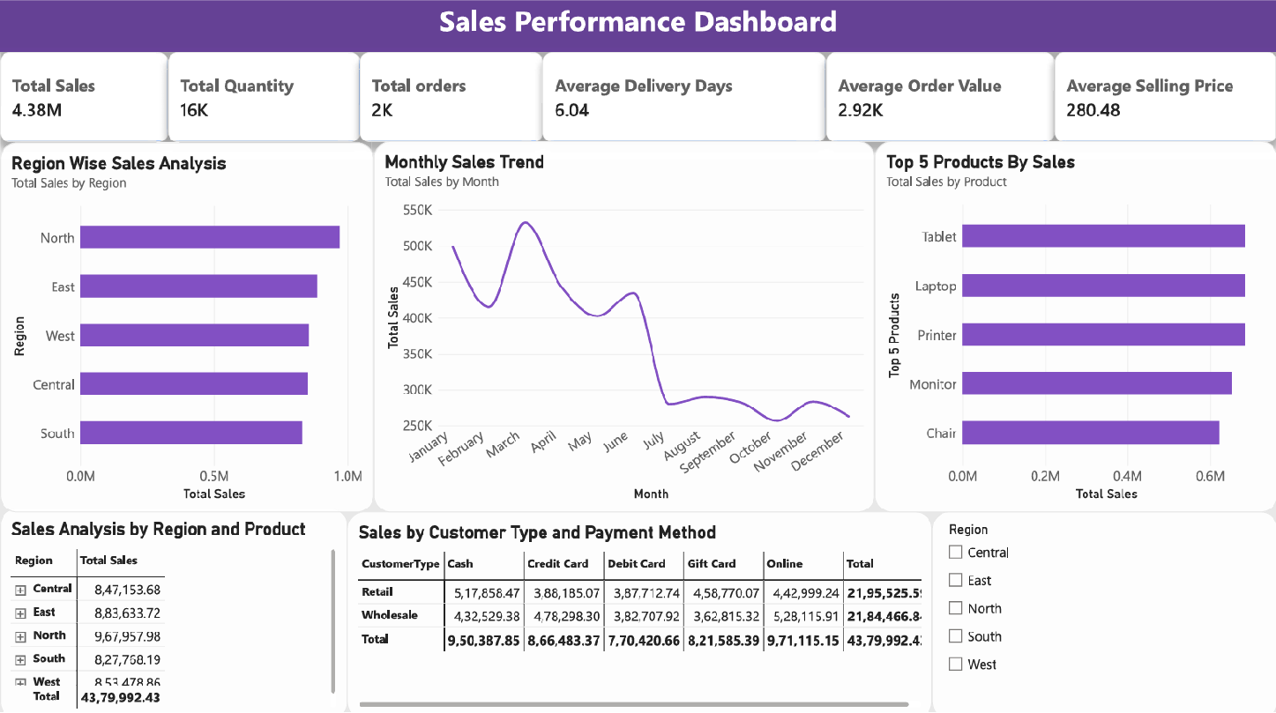
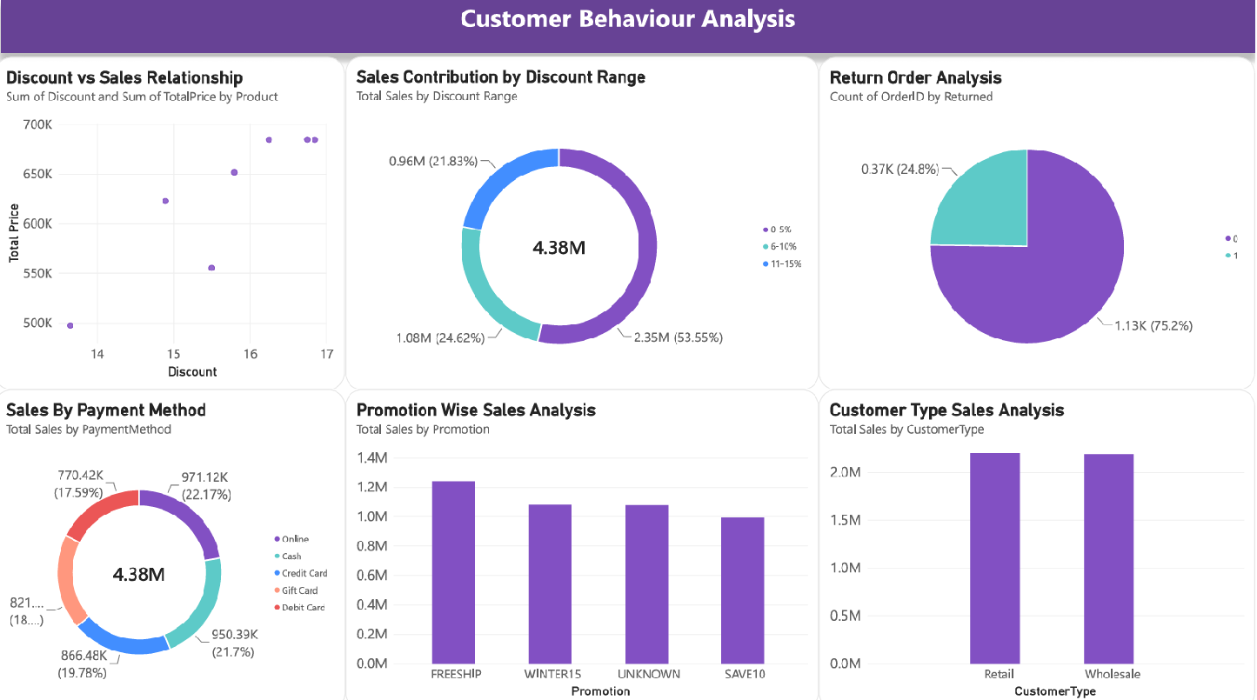
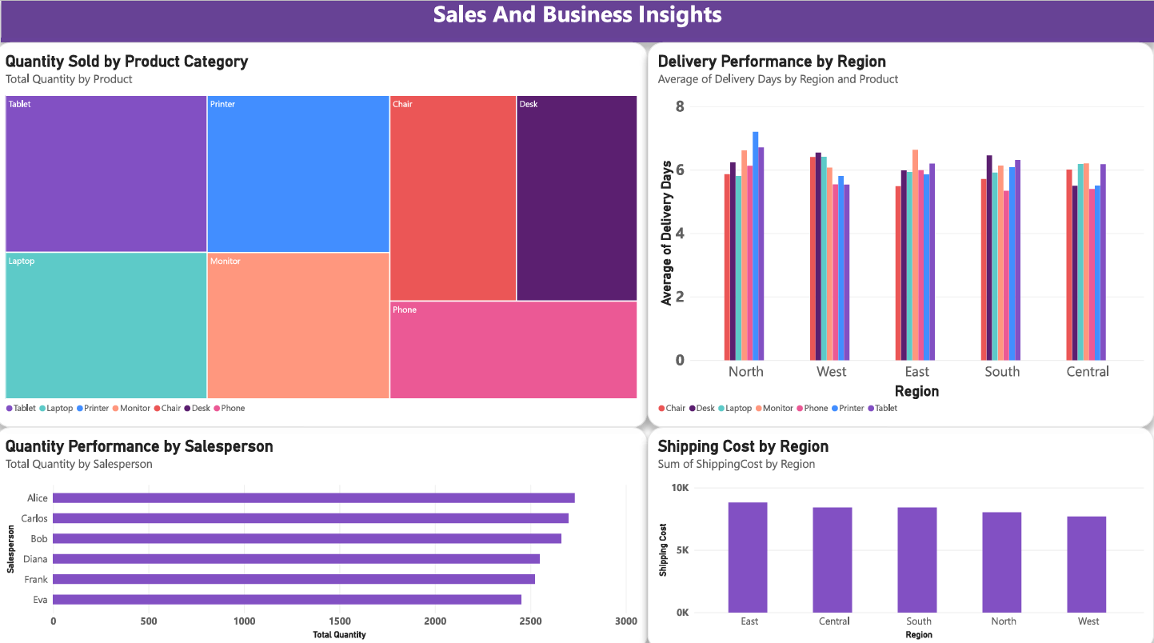

9. Insights & Conclusions
Key Findings: The dashboard identifies patterns across customer types, regions, products, payment methods, promotions, discounts, and sales periods. It also supports analysis of quantity sold, returns, delivery performance, and shipping costs.
Descriptive Analysis
- Analysed monthly sales trends and compared sales across regions and customer types.
- Identified top-performing products and reviewed sales contribution by discount range and payment method.
- Examined quantity sold, return orders, promotions, delivery performance, and shipping costs.
Diagnostic Analysis
- Compared regional results to identify performance differences.
- Analysed the relationship between discounts and sales using a scatter chart.
- Compared customer types and payment methods, and reviewed promotion and discount contributions.
- Examined delivery performance and shipping costs to identify operational differences.
Predictive Analysis
- Monthly and regional sales patterns may indicate future sales trends.
- Historical product, customer-type, and regional performance can support future sales estimates.
- Discount and promotion patterns may indicate their possible effect on future sales.
Prescriptive Analysis
- Focus on high-performing products and regions to improve overall sales performance.
- Apply discount and promotion strategies based on observed contribution to sales.
- Review low-performing regions, products, and customer segments for improvement opportunities.
- Monitor delivery performance and shipping costs to improve operational efficiency.
- Use dashboard insights for sales planning and data-driven decision-making.

10. Conclusion
The integration of Excel and Power BI provides an effective end-to-end approach for cleaning, transforming, analysing, and visualizing sales data. The consolidated interactive dashboard gives users a clear view of sales performance and highlights business patterns that can support informed decision-making.

